CREATE SQL USING TERRAFORM

TABLE OF CONTENTS

1. INTRODUCTION 3
2. OBJECTIVES 4
3. CREATE CLOUD SQL USING TERRAFORM 5
4. INSTALLING THE CLOUD SQL PROXY 14
5. TEST CONNECTION TO THE DATABASE 15

INTRODUCTION

- Terraform enables you to safely and predictably create, change, and improve infrastructure. It is an open source tool that codifies APIs into declarative configuration files that can be shared amongst team members, treated as code, edited, reviewed, and versioned.

OBJECTIVES

- Create a Cloud SQL instance
- Install the Cloud SQL Proxy
- Test connectivity with MYSQL client using Cloud Shell

CREATE CLOUD SQL USING TERRAFORM

- In the GCP console, on the top right toolbar, click the open cloud shell button.
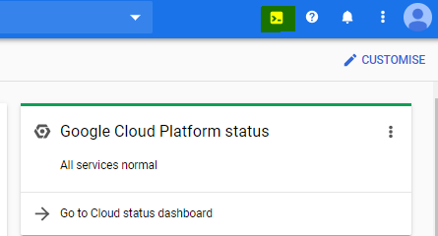

- You can list the active account name with the command mentioned below

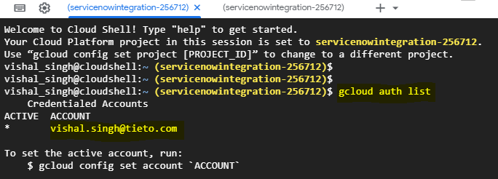

- You can list the project id with the command mentioned below:

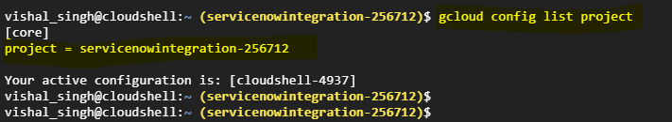

- Check the terraform version pre-installed in the Cloud Shell using command “terraform version”

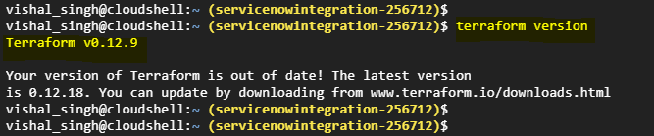

- Create a directory using command “mkdir” and fetch required Terraform scripts from the Cloud storage bucket.

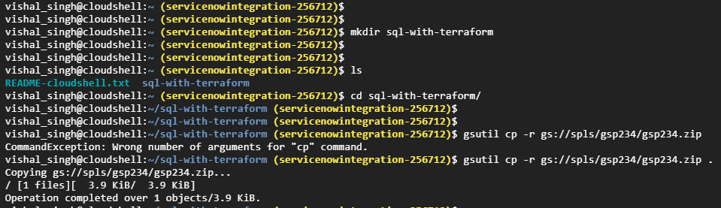

- Unzip the downloaded content and “cat” the “main.tf” file to go through the contents inside the file.

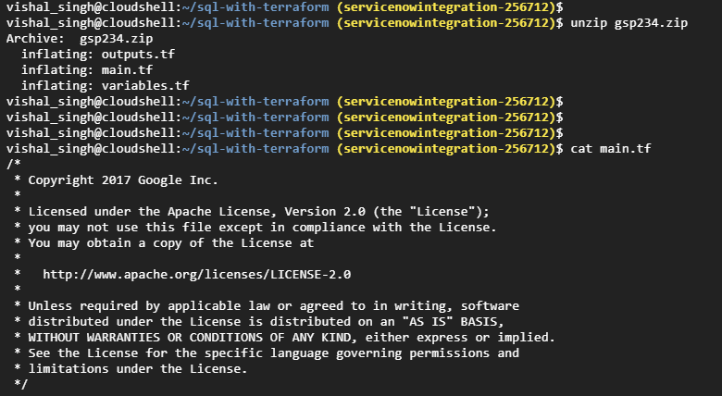
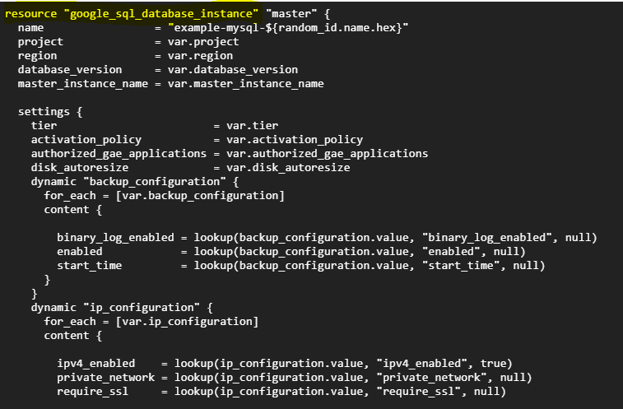

- The “terraform init” command is used to initialize a working directory containing terraform configuration files. It performs several different initialization steps in order to prepare a working directory for use.

- It can be used several times to bring the working directory up to date with changes in the configuration.

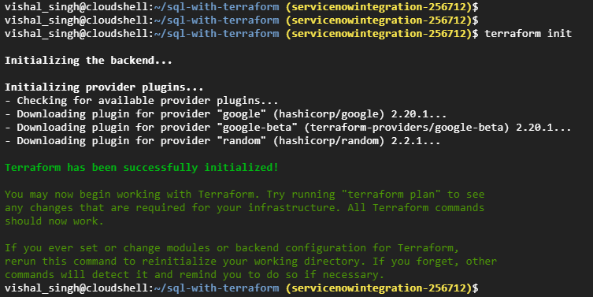

- “terraform plan” is used to create an execution plan.
- The optional -out argument can be used to save the generated plan to a file for later execution with terraform apply.
- “terraform plan -out=tfplan” command saves the generated plan to tfplan file.

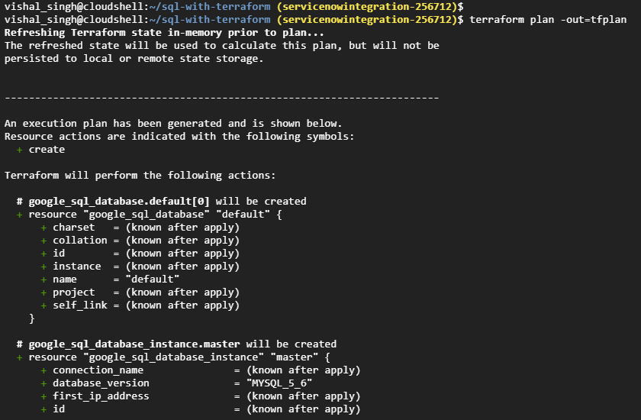

- Below image display what all task which are planned, will be performed.

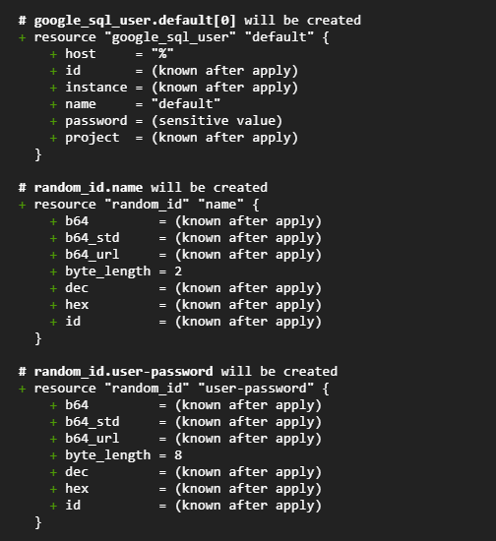

- The “terraform apply” command will apply the changes required to reach the desired state of configuration

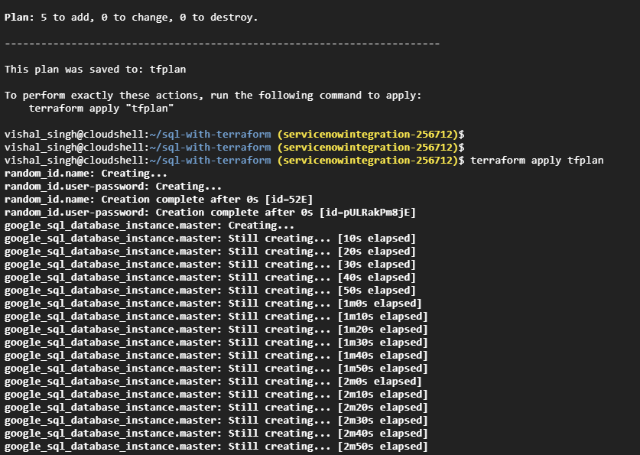

- Cloud SQL with instance name “example-mysql-e761” is created

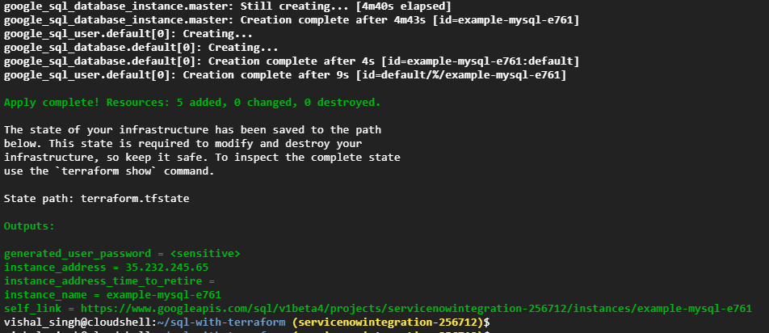

- Login to you “Google Cloud Console” and check the Cloud SQL is created.

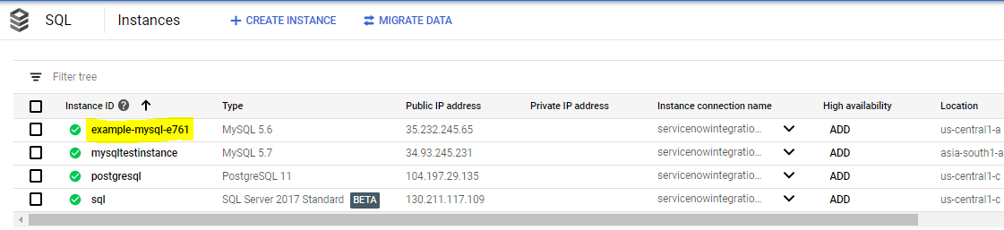

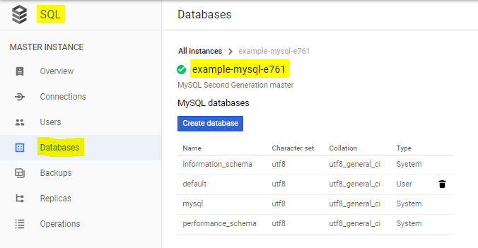

INSTALLING THE CLOUD SQL PROXY
- The Cloud SQL Proxy provides secure access to your Cloud SQL instances without having to whitelist ip address or configure SSL.
- Accessing you SQL using SQL Proxy offers these advantages:
- Secure Connections: The proxy automatically encrypts the traffic to and from the database.
- Easier connection management: The Proxy handles authentication with Cloud SQL, removing the need to provide static IP addresses.

- Download the proxy using the below command.

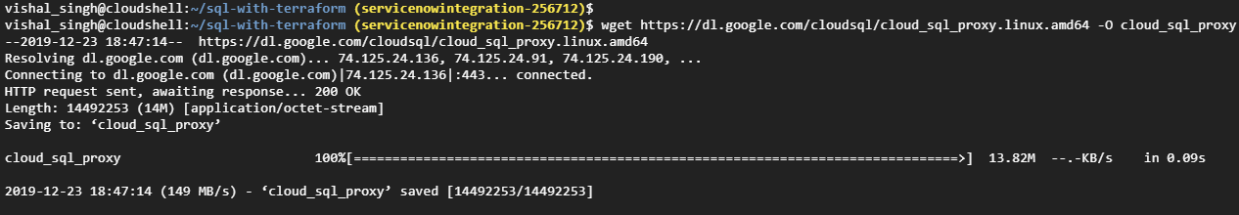

- Make the proxy executable

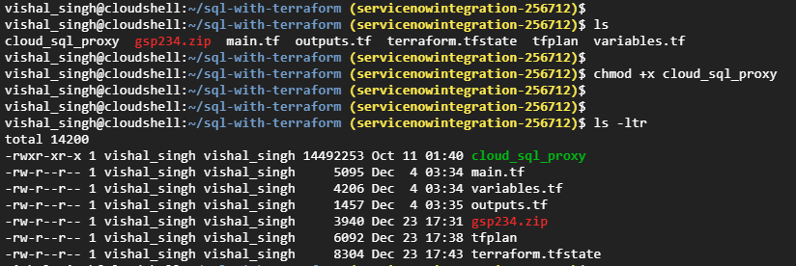

TEST CONNECTION TO THE DATABASE

- Start by running the Cloud SQL proxy for Cloud SQL Instance.

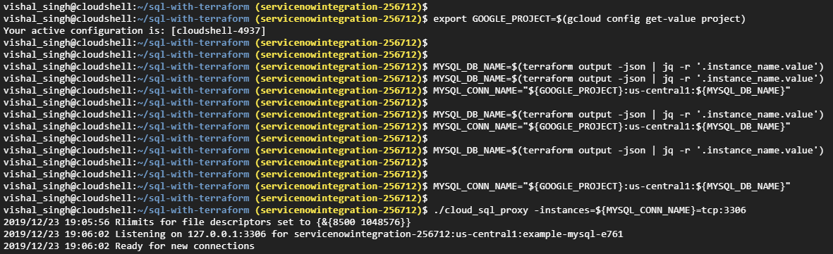

- Now start another tab and we will use this shell to connect to the Cloud SQL Proxy.

- Navigate to “sql-with-terraform” directory and get the generated password for MYSQL.

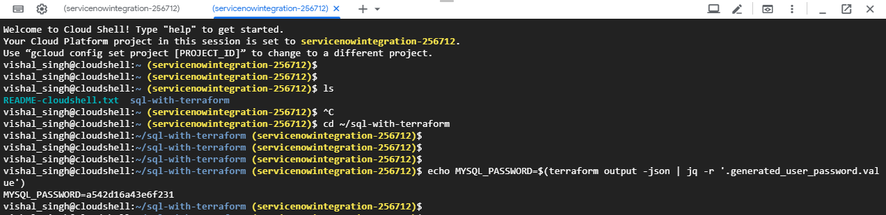

- Test the MySQL connection:

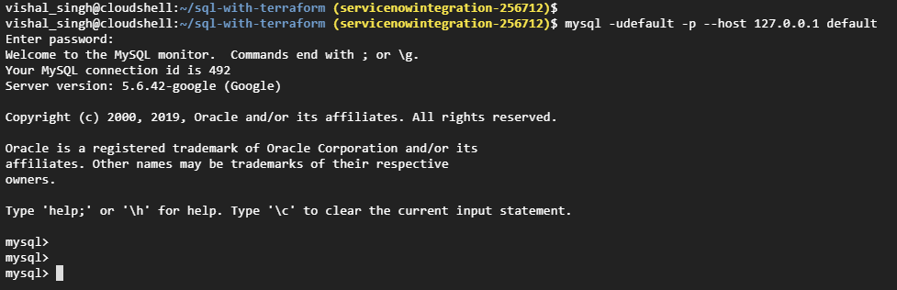

- Now go back to your 1st Cloud Shell tab you will see logs for the connections made to the Cloud SQL Proxy

